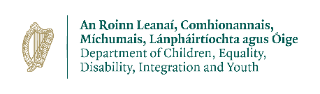
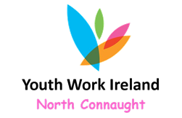
Youth Work Ireland North Connaught
Leitrim UBU Youth Project
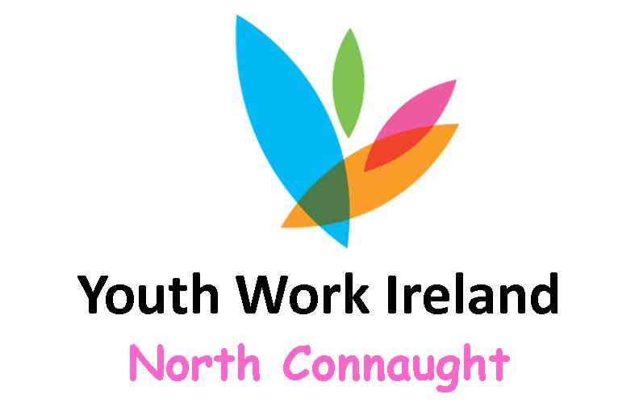
Youth Development Officer
Youth Work Ireland North Connaught promotes and fosters youth development through the operation of various youth projects in urban and rural areas in the Northwest, through the Department of Children and Youth Affairs Your Place Your Space Funding Scheme, invite applications for the following position:

Youth Development Officer- Leitrim UBU Youth Project
(28 hours per week)

Leitrim UBU Youth Project seeks to facilitate the personal and social development of participants to realise their potential and in particular to equip them with the knowledge, skills, and attitudes necessary for their appropriate integration in society; presenting opportunities for young people to undertake actions corresponding to their own aspirations and to assume responsibilities within their local communities.

The focus in on co-creation and co-development in partnership with young people, a minimum of 80% of all provision offered will be for young people aged 10-24 years. The remaining 20% of services can be open to all young people or can be focused on young people with more complex needs.

The successful applicant(s) will have the following essential requirements:

- Education to degree level in Youth Work (or other social science relevant discipline) and a minimum of 1 years’ experience within the sector.
- Full clean driving licence.
- Relevant paid or voluntary experience of working with young people.
- Demonstrate the capacity to engage with the 10-24 aged cohort of young people.

PLEASE VIEW THE JOB SPECIFICATION BELOW FOR FULL DETAILS ON ALL REQUIREMENTS.

Applications for this vacancy should be made by way of YWINC Job Application form only.

The full job spec and YWINC application form can be downloaded from this page (see below) and is also available to download from our website www.ncycs.ie (http:/www.ncycs.ie)

Closing date for receipt of application is 1.00 p.m. on Tuesday 22nd June 2022.

Please note: A panel may be formed from which future positions funded from a variety of sources may be filled.

YWINC is committed to a policy of Equality of Opportunity in its employment practices.

